**Expiry Dating Calculation**

Time unit (days/ weeks/ month)

Add these options for the customers

Customers can pick from drop down

menu or add it

Values (Potency/ Related Compounds/ Total Impurity/ Others)

Upper Limit (Values)

Lower Limit (Values)

Add y-axis title like you see on excel

Time Value

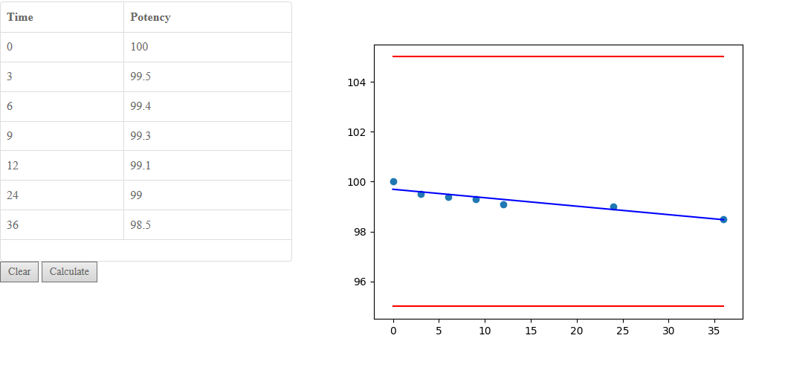

Time (unit)



Add x-axis title

x-axis is always time

but the unit will be different based on customers input